ATTACHMENTS AND HEADGEAR COMPONENTS

Humble hook
Spectacle plate
Jack catches
Compensating wheel
The Guillotine and its purpose
The purpose of a crosshead and its components

INTRODUCTION

HUMBLE HOOK
Operation of a Humble hook
How to prepare a Humble hook for N.D.T. (non-destructive test)
Identification of defects
Special precautions
Numbering of a Humble hook
Assembling a Humble hook
Various methods of attaching a rope to a Humble hook
Winding socket
Thimble splice
Capel
Examination of a Humble hook

SPECTACLE PLATE

JACK CATCHES

COMPENSATING WHEEL

THE GUILLOTINE AND ITS PURPOSE

THE PURPOSE OF A CROSSHEAD AND ITS COMPONENTS

LOCATION OF CRASH BEAMS, CRASH DOORS, JACK CATCHES,

TRIGGER AND ARRESTORS DURING SINKING OPERATIONS

INTRODUCTION

Owing to much improved mechanical and electrical safety devices and controls for winding plants, the possibility of an overwind, due to human error, is greatly reduced.
Human lives are dependent on the safe and proper functioning of attachments and headgear components. Persons responsible for the maintenance and testing of these components must have a thorough knowledge of how these components operate.
In this module we will deal with attachments and headgear components.

HUMBLE HOOK

Let us first identify the various components of a safety detaching hook, better known as a Humble hook, shown in Fig. 1.
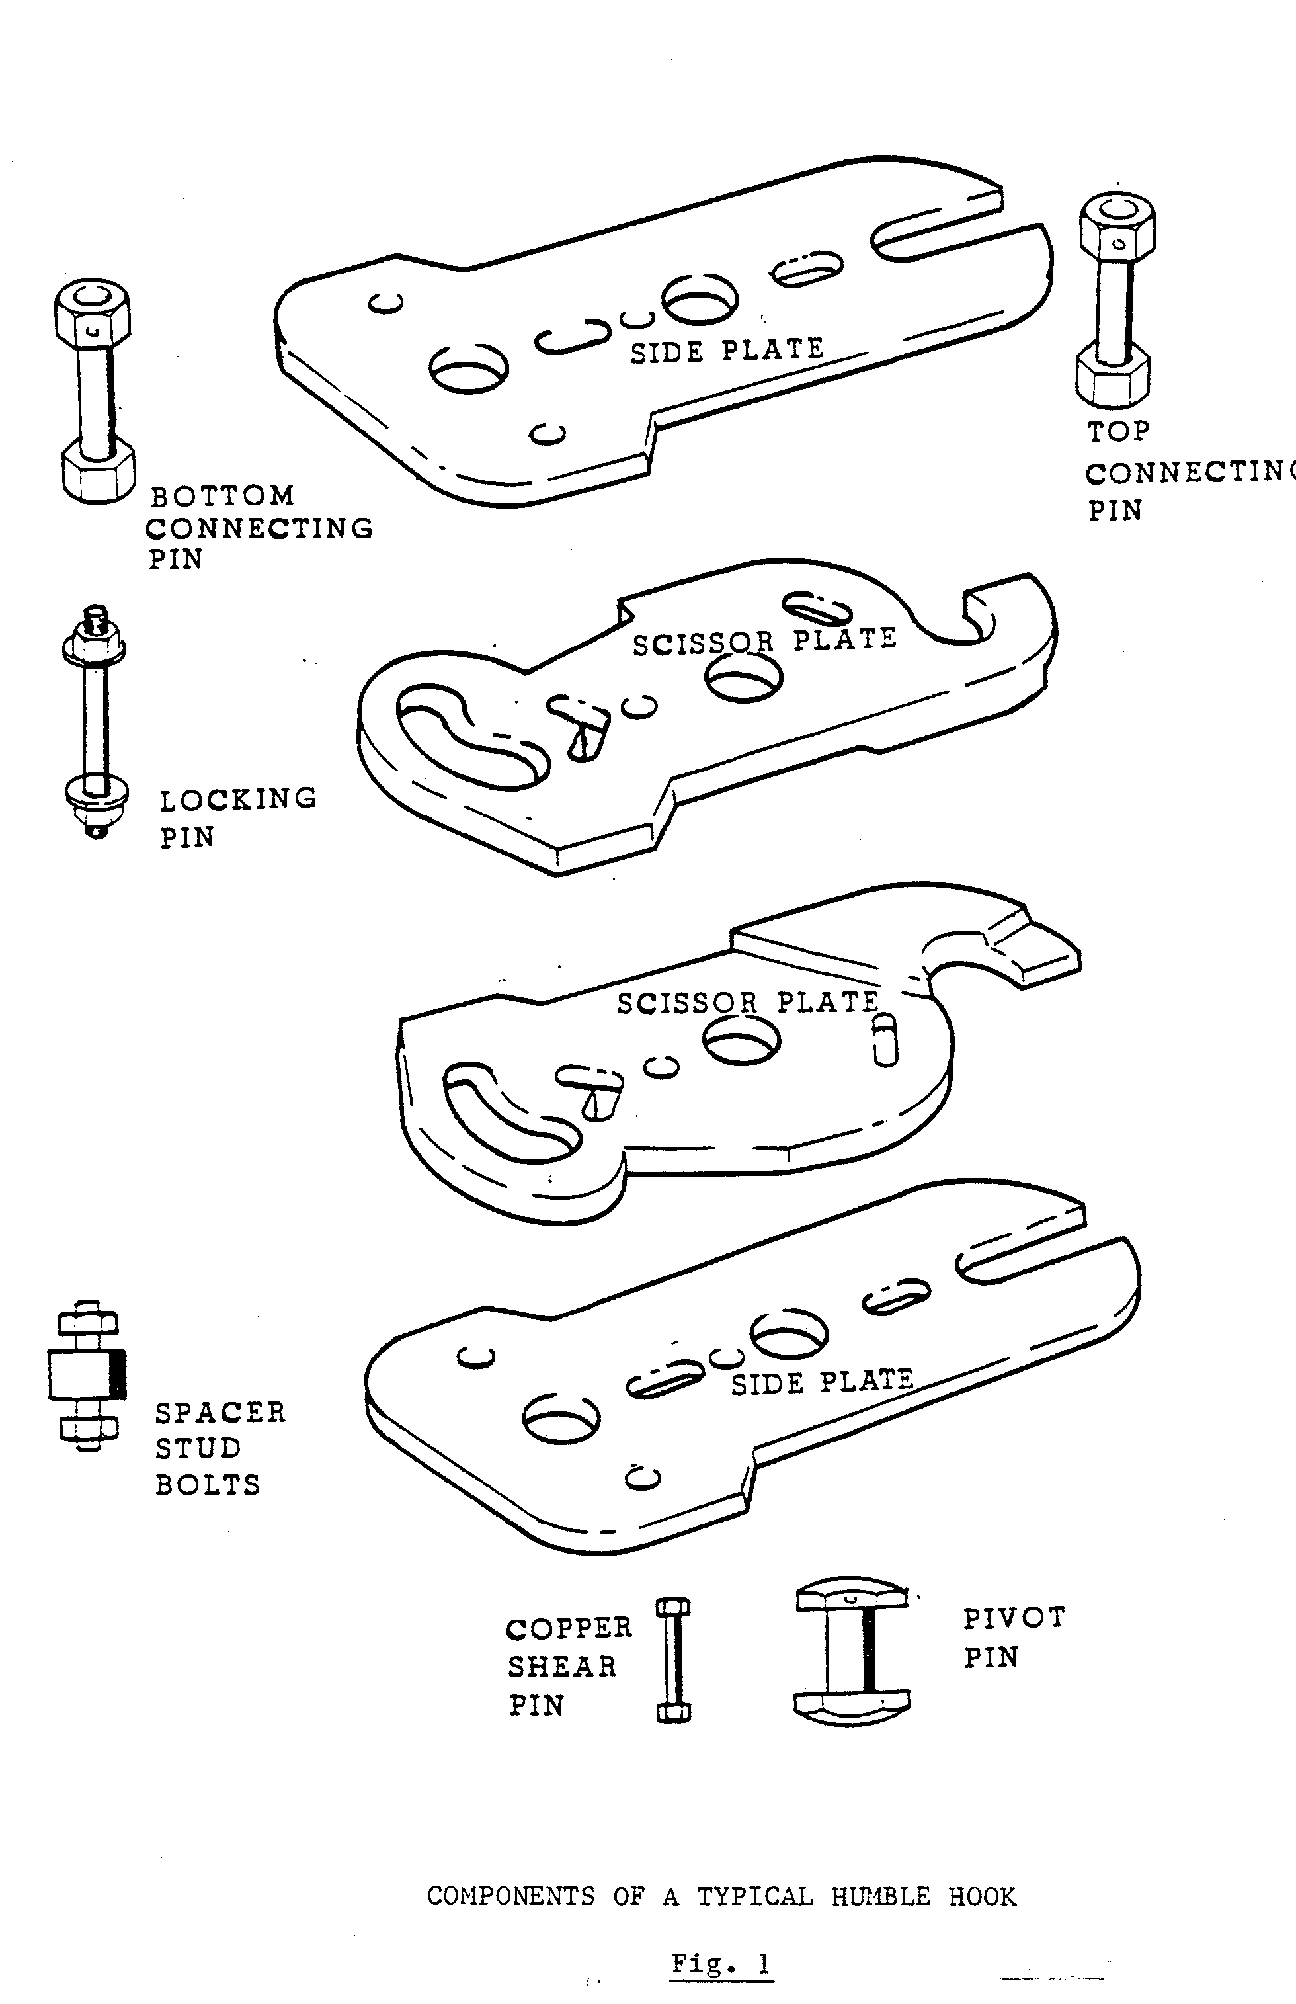

Operation of a Humble hook

In the event of an overwind, the Humble hook, when entering the spectacle plate, will rise until the scissors plates strike the underside of the spectacle plate, as illustrated in Fig 2.

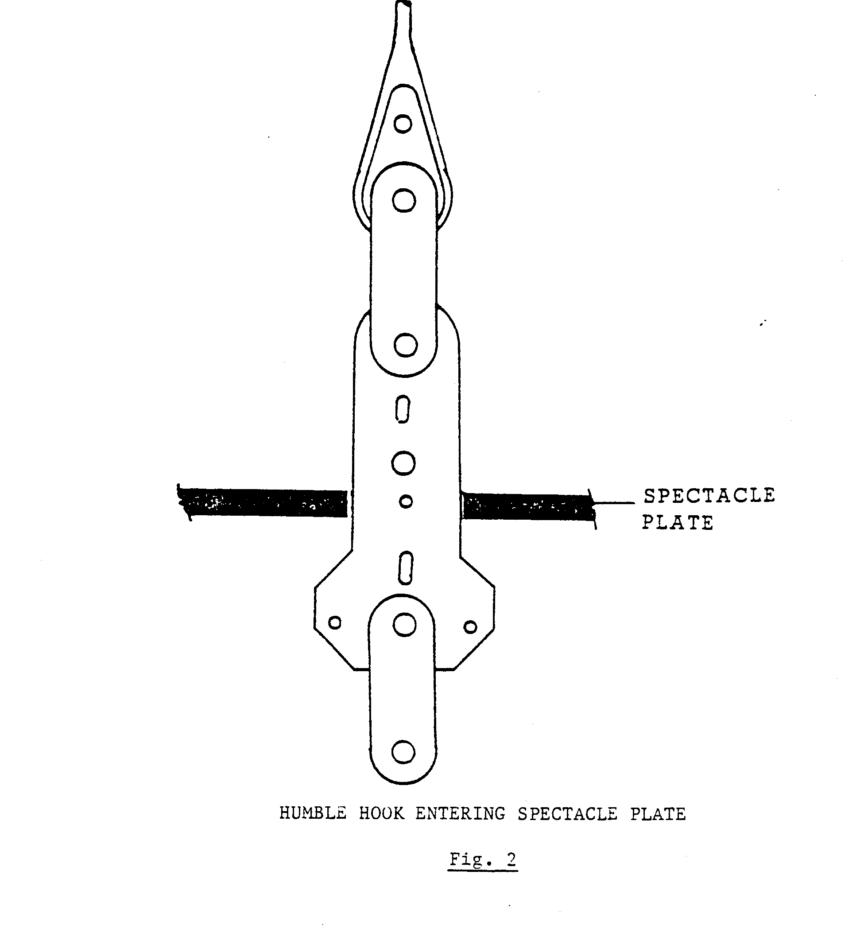
On impact, the scissors plates immediately start opening, shearing the copper pin. The scissors plates fulcrum about the scissors plate pin, the lower ends closing and upper ends opening. When the Humble hook scissors plates open to their maximum, they will release the top attachment and rope. Once the rope is released, the locking pin drops into the slot position, to ensure that the scissors plates remain open. The hook body now drops back onto the tongue or catch projections on the opposite sides of each scissors plate and comes to rest on the spectacle plate as illustrated in Fig. 3.

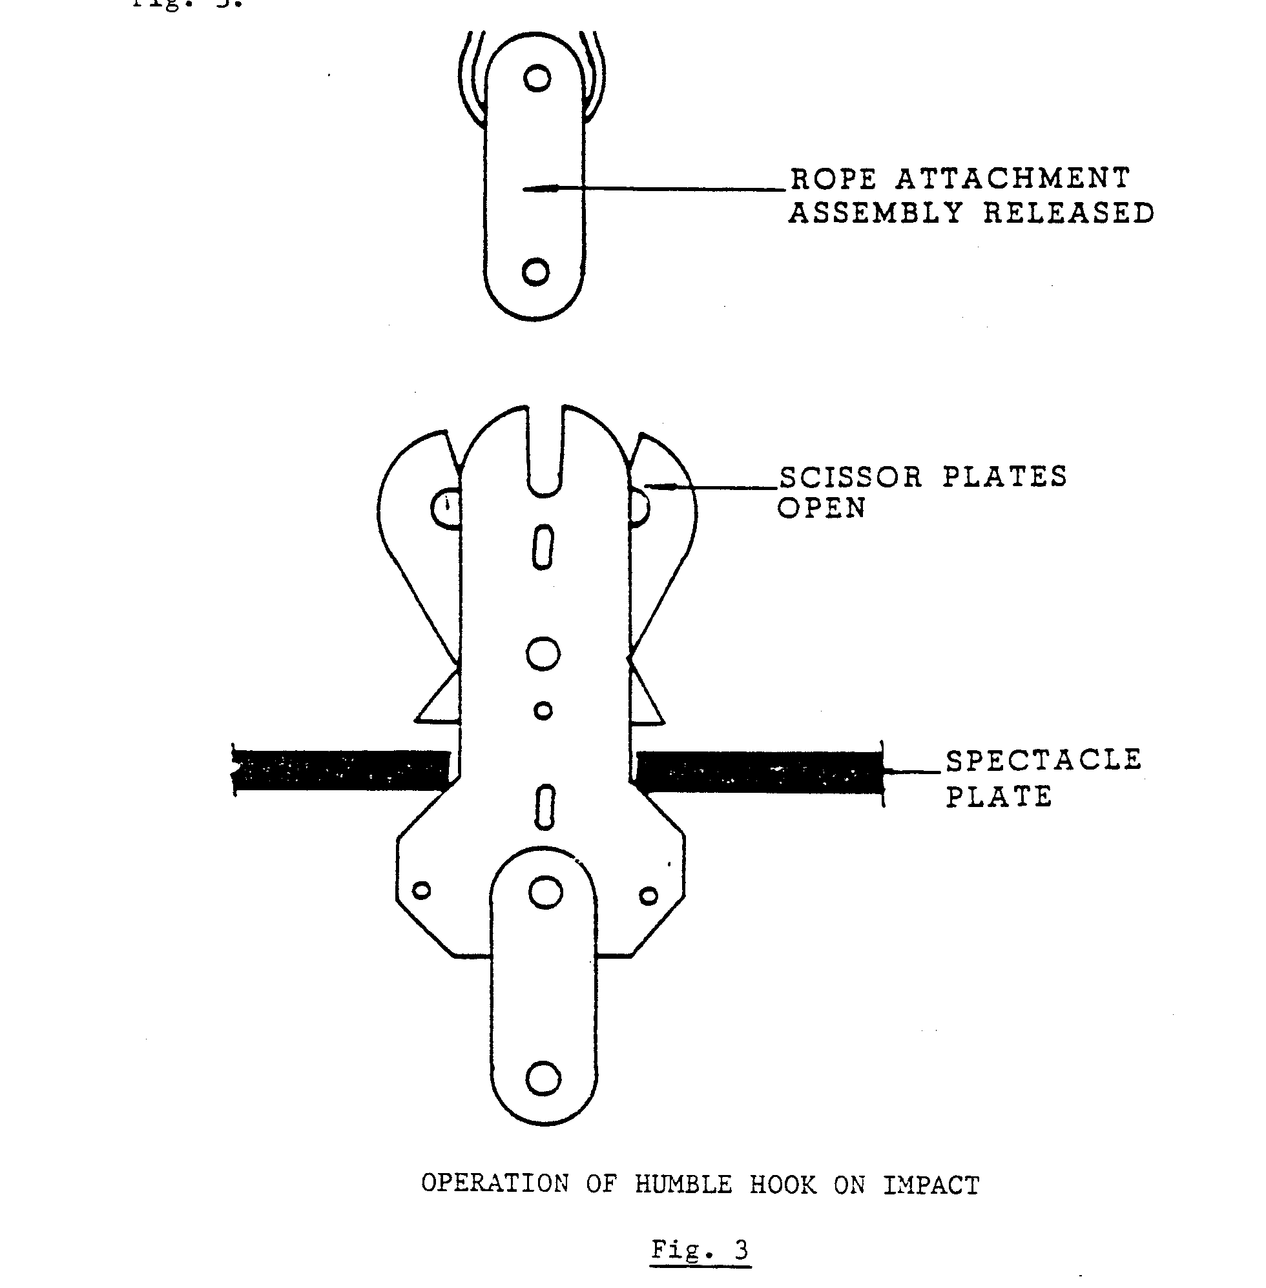
The Humble hook, links, pins and drawbars are manufactured to A.A.C. standards and specifications from 1.5% manganese steel, known as mangear, and do not require periodic heat treatment as laid down in the Mines and Works Act and Regulations No. 16.18.
They are stored and rested for six months to be stress-relieved after they have been inspected and N.D.T.
How to prepare a Humble hook for N.D.T. (non-destructive test).
After a Humble hook has been in use for six months, the hook must be examined and tested as stated in the Mines and Works Act and Regulations No.16.18.

“Annealing

At intervals of not more than six months the connections between –
- Any winding rope and the conveyance or counterpoise,
- The conveyance and any trolley, trailer or other attached conveyance, and
- Any balance rope or tail rope and the conveyance or counterpoise,

Shall be annealed or given other proper heat treatment or shall be discarded and replaced. With connections of a class of steel approved by the Government Mining Engineer, the interval for heat treatment may be extended with the written permission of the Government Mining Engineer.”

Prepare the Humble hook for N.D.T. as follows:

- The Humble hook must be completely stripped and cleaned of any rope dressing, grease and corrosion.

- Check the side plates, scissors plates and links for flatness of surface by means of a straight edge.

- Inspect all pins for wear and side play in the holes.

- Examine the nuts on the pins for excessive play on the threads.

- Inspect the copper pin for wear and partial shear due to wear and slackness in the side and scissors plates.

- Ensure that records are available when the N.D.T. and examinations are carried out, and that all work done on the Humble hook is recorded in the Humble Hook Record Book and the Machinery Record Book for future references.

Identification of defects

To identify any defects on the Humble hook links, pions and drawbars, the following must be checked:

- The pins and the pin hole clearances must be checked and measured to your mine’s Humble hooks manufacturer’s specifications, specifying the wear limits for pins and holes in suspension equipment.

- Examine both side plates opposite the scissors plate and bottom pin holes to ensure that no cracks exist.

- When shackles are being used to attach the Humble hook to the rope, the shackle bows should be inspected for cracks and undue wear at bearing points. Examine the holes in shackle eyes for cracks, wear and elongation.

- Examine the scissors plates opposite top pin to ensure that no cracks exist. Check that no indentations appear around this neck section of the scissors plates. The greatest applied load distribution is across the neck section of the sicker plates.

- Examine all scissors side plates and links for flatness by means of a straight edge.

- Examine all nuts and split pins for wear and slackness. Renew split pins at regular intervals.

Special precautions

1. On no account should cracks, which are detected on a Humble hook or its components, be welded.
2. No heat must be applied to mangear (which is the Material used for Humble hooks of their components).
3. All defective components must be destroyed immediately.

Numbering of a Humble hook

Identification marks should be visible when assembled. No marls should be stamped on working faces, or in a position where they may act as stress raisers. a method of numbering a Humble hook is illustrated in Fig 4.

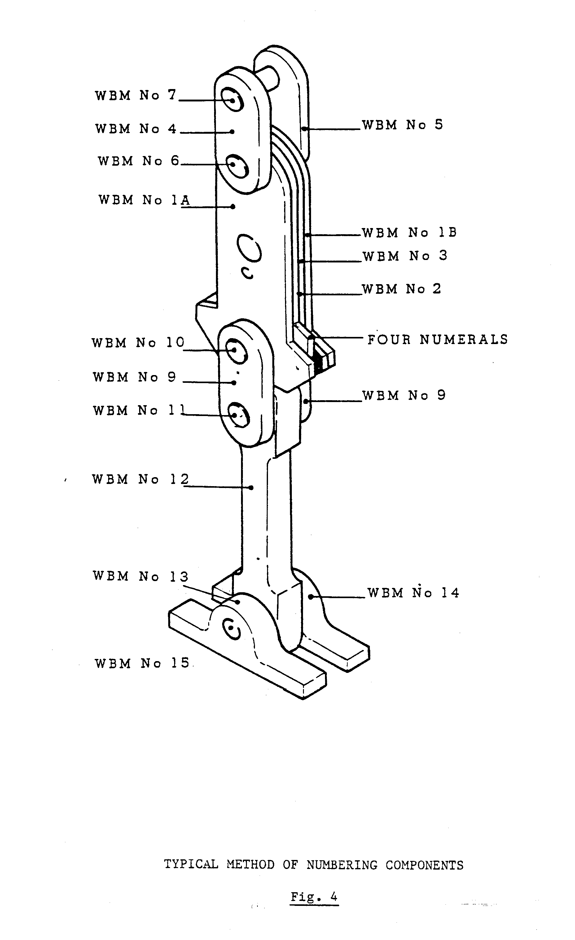
The Mines and Works Act and Regulations No. 16.19 states:

“A proper record shall be kept of the heat treatment and working life of the connections referred to in regulations 16.18 and a person appointed in terms of regulations 2.13.1, 2.13.2 or 2.13.3 shall add to the record his report on the method and procedure followed in such treatment and his comments on the results. All such connections and their component parts shall be marked clearly for the purpose of identification”.

Assembling a Humble hook

When assembling a Humble hook, always ensure that the side and scissors plates are fitted in the correct manner, by referring to the identification marks on the plate’s edges. The marks can be in the form of letters or numbers. Always ensure that all the Humble hook components are cleaned after the N.D.T.

The following is a recommended method of assembling a Humble hook:

- Smear an adequate amount of grease on the pins and butting faces of the side and scissors plates. (Lubricant must be according to A.A.C. specification). Insert the pivot pin and spacer stud bolts in the one side plate.

- Place the scissors plates in position according to the identification marks.

- Place the other side plate in position and hand-tighten the nuts on the pivot pin and spacer stud bolts.

- Fit a mild steel stud bolt in the place of the copper shearing pin. (The bolt should be the same size as the shearing pin, as this mild steel bolt is used in place of a transport clamp). The mild steel stud bolt must be removed on site when the Humble hook is replaced. Only then can the copper shearing pin be fitted.

- Tighten the nuts on the pivot pin and spacer stud bolts and fit split pins.

- Fit the top links and pins.

- Fit the column links, pins and drawbar, dead eye and pin.

- Paint the Humble hook with an anti-corrosive paint, according to your mine’s specification. (Some mines use rope dressing, smeared over the Humble hook as a corrosive treatment or paint it with copperslip.) When a Humble hook is completely assembled, it should be stored in a vertical hanging position as illustrated in fig. 5.

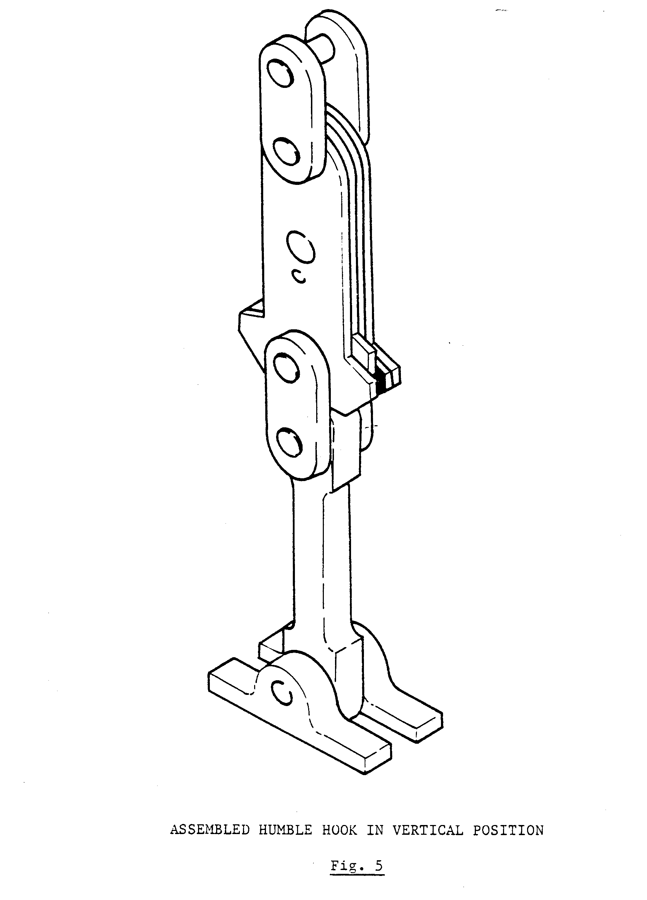
Various methods of attaching a rope to a Humble hook

Fig. 6 illustrates three methods of connecting winding ropes to Humble hooks.

1. Winding socket.
2. Thimble splice.
3. Caple.

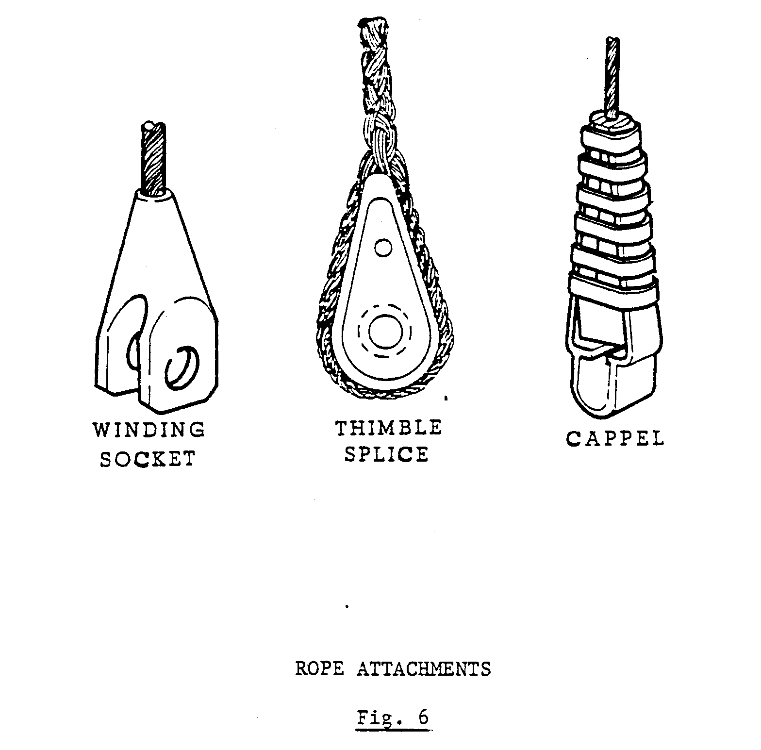
Winding socket
Winding sockets are normally used where headroom between the spectacle plate and sheave wheel is restricted. Winding sockets can be attached direct to the Humble hook, obviating the necessity for top coupling links.
Thimble splice
The thimble splice is normally used on man and material conveyances. This splice is connected to the Humble hook by means of two top links and pins.
In the event of an overwind, the top links and thimble are detached from the Humble hook.

Capel

Capels can be used in all types of hoisting systems. When fitted to multi-rope friction hoists the compact design permits close rope centres.
When fitted to a Humble hook, care should be taken particularly where headroom between the spectacle plate and sheave wheel is restricted. In the event of an overwind, the rope connection to the Humble hook should not make contact with the sheave wheel before the rope is detached from the Humble hook.
Ensure that adequate clearance exists between the spectacle plate hole and all attachments, including rope capel, so that unrestricted passage through the spectacle plate is possible. Avoid the use of pins fitted with flat cotters on and above the Humble hook.

Examination of a Humble hook

The importance of the Humble hook cannot be over-emphasized and all examinations should be done thoroughly.

The following items are to be examined daily:

- Examine all locks, nuts and splits pins.

- Check the copper pin for free movement, by tapping it with a light hammer and hand-feel over the radius of both sides of the hook for any movement between the side and scissors plates.

- Inspect the complete Humble hook and attachments for any signs of damage.

- Inspect the rope immediately above the Humble hooks for any signs of damage.

The Humble hook should be cleaned with a recommended cleaning solvent according to your mine’s specifications (Paraffin). After the cleaning process, smear a thin layer of grease or oil over the complete Humble hook.
Before starting with the daily examination, an entry must be made in the Winding engine Driver’s logbook and signed immediately after the completion of the daily examination. The entry must be cleared and signed by the responsible person who did the examination.

SPECTACLE PLATE

The purpose of the spectacle plate is:

- To detach the winding rope from the Humble hook in the event of an overwind.

- When an overwind has occurred, and the rope is detached from the Humble hook, the hook body drops back and comes to rest on the spectacle plate, thus preventing the conveyance from falling back onto the jack catches, which are a secondary safety device in case of a Humble hook failure.

The spectacle plate is installed below the sheave wheel and is matched to the Humble hook. The minimum between the sheave wheel and spectacle plate must be so that the rope can be detached before the rope connections come in contact with the sheave wheel on the event of an overwind.
Ensure that the spectacle plate hole is centrally aligned with the winding rope and that adequate clearance exists between the spectacle plate hole and attachments, including rope capel, so that unrestricted passage through the spectacle plate is possible.
Ensure that the lowering shackle (for release of the hook after overwind) is maintained in a clean and corrosion-free condition. Use the correct shackle for the hook in use and always ensure that all key personnel know where the shackle is located.
After an overwind, the spectacle plate must be thoroughly inspected. Inspect all securing bolts, holding-down bolts and crash beams for any defects caused by the overwind.

JACK CATCHES

The provision of headgear jack catches reduces the possibility of the conveyance falling back into the shaft, in the event of an overwind. Fig. 7 illustrates two sets of jack catches installed in one side of a compartment.

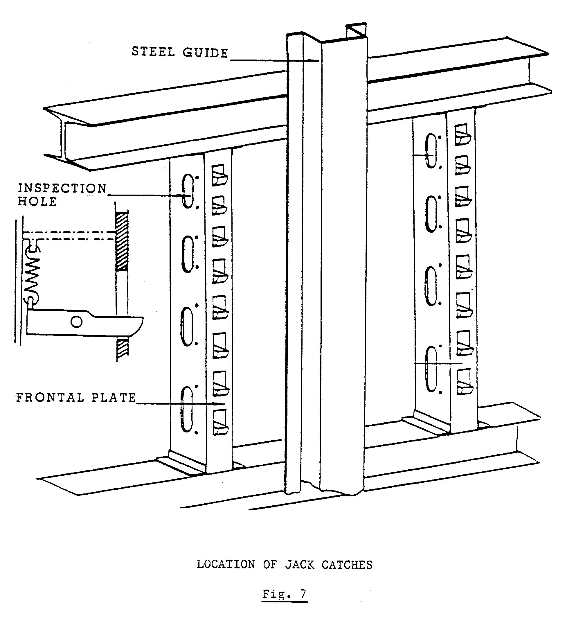
Most jack catches are spring-loaded and should be inspected at least once a week. During such an inspection, the free movement of each catch must be checked. If necessary, it should be greased. Bushed catches will operate without grease; this helps to prevent the accumulation of dust, which may retard easy functioning.
For smaller types of conveyances, the same type of jack catches are used with the exception that they are installed in the steel guide as illustrated in Fig. 8.

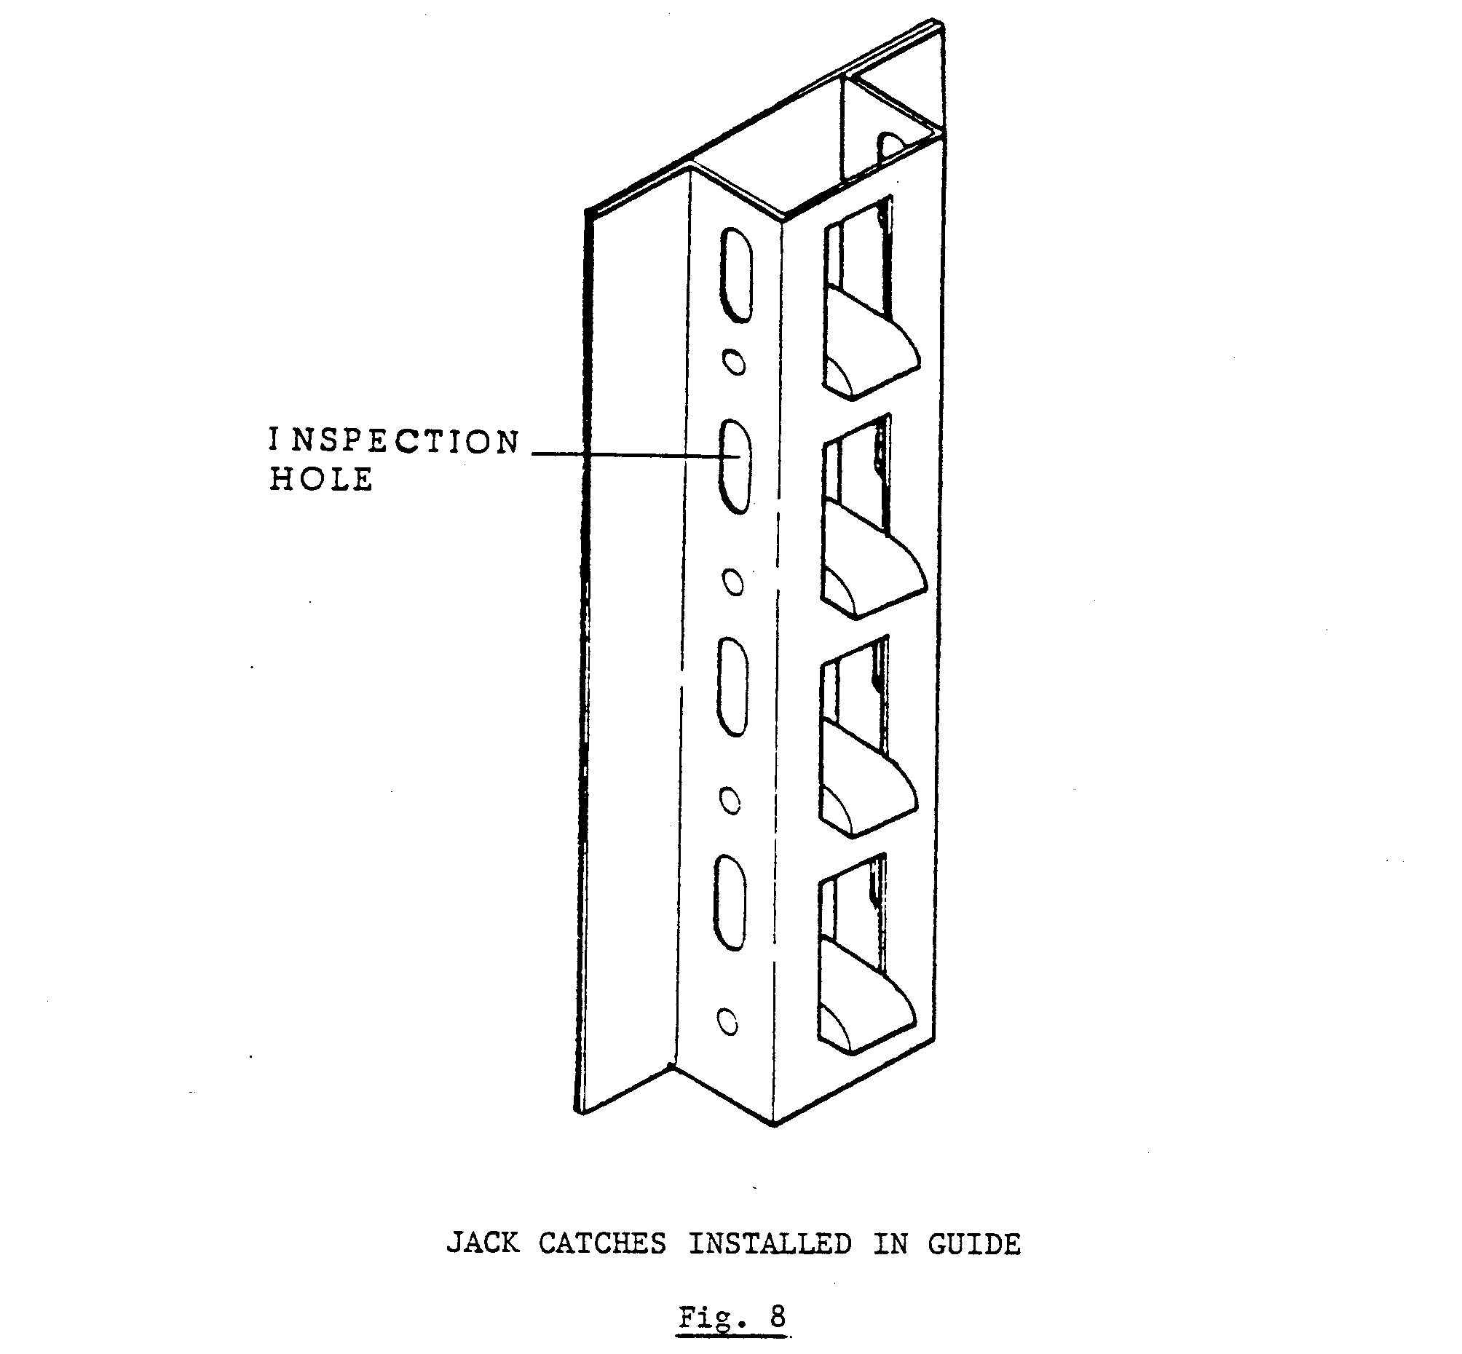
In vertical sinking shafts where jack catches are installed and kibbles used, four sets of jack catches are employed per compartment. Fig. 9 illustrates an arrangement and detail of this type of jack catch installation. The advantage of this type is that the jack catches are instantaneous and positive in operation.

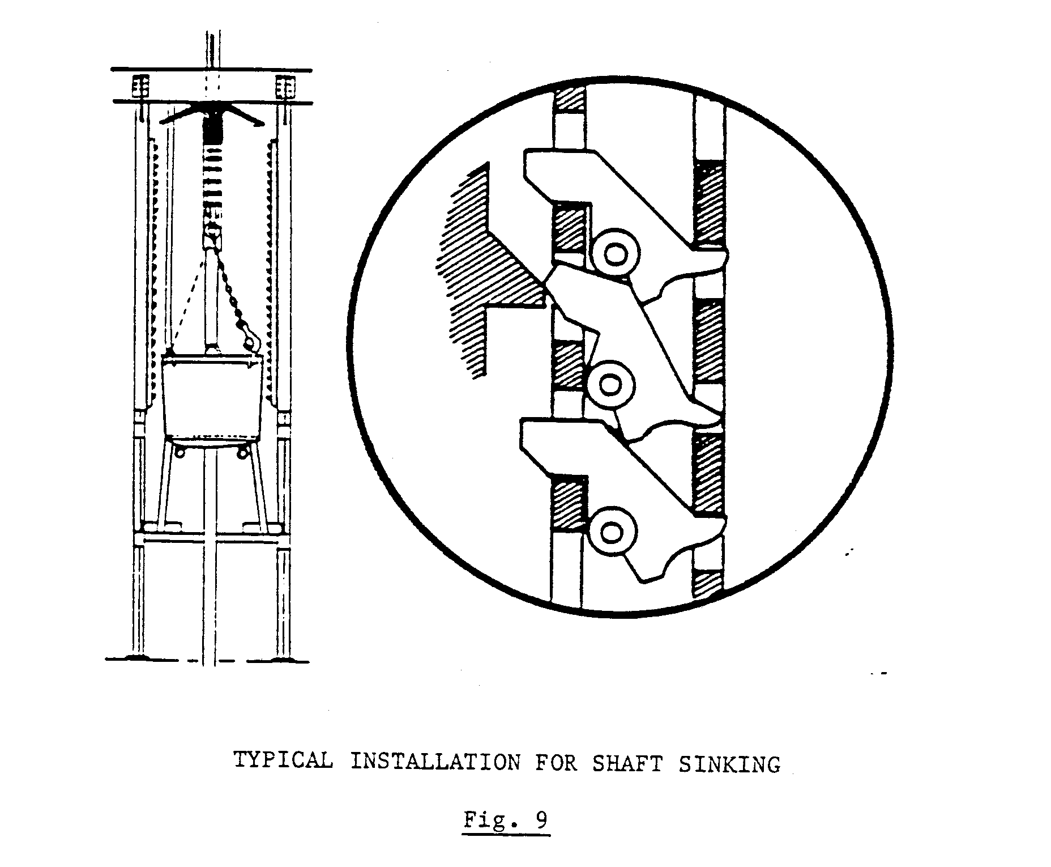
The Mines and Works Act and Regulations No. 16.57 states:

“Where winding is carried on in a shaft there shall be fitted above the bank spring keps or jack catches or some other effective contrivance to support any conveyance detached from the winding rope as a result of an overwind.”

COMPENSATING WHEEL

The compensating wheel is a short helical-grooved drum, having single continuous threads with a small number of turns, and a bottom diameter, corresponding exactly with the horizontal distance between the two parallel winding ropes.
The two ropes are wound from the centre of the pulley around the perimeter of the rim of the wheel towards its respective outer edges and carried via a transition arc to a clamping mechanism, consisting of a rotating quadrant with a grooved periphery in the shape of a true archimedean screw facing a matching spiral segment with an identical groove machined on its inside to the actual radius of the rope diameter.
This form of rotary wedge capel is completely self-locking and maintains rope grip without slip beyond the breaking strength of the rope.

The Mines and Works Act and Regulations No. 16.32 states:

“Where a conveyance is suspended by two or more winding ropes, the ropes shall be of approximately equal size and strength. Adequate arrangement s shall be made to equalize the tension in the ropes and, in calculating the breaking force of the ropes, each rope shall be assumed to carry an equal share of the load”.
The number of turns per side of the sheaves is determined by the relative maximum displacement between the ropes, which can occur temporarily, if change-over between rope layers on a twin rope hoist drum should not coincide exactly in line. The compensating wheel is illustrated in Fig. 10.

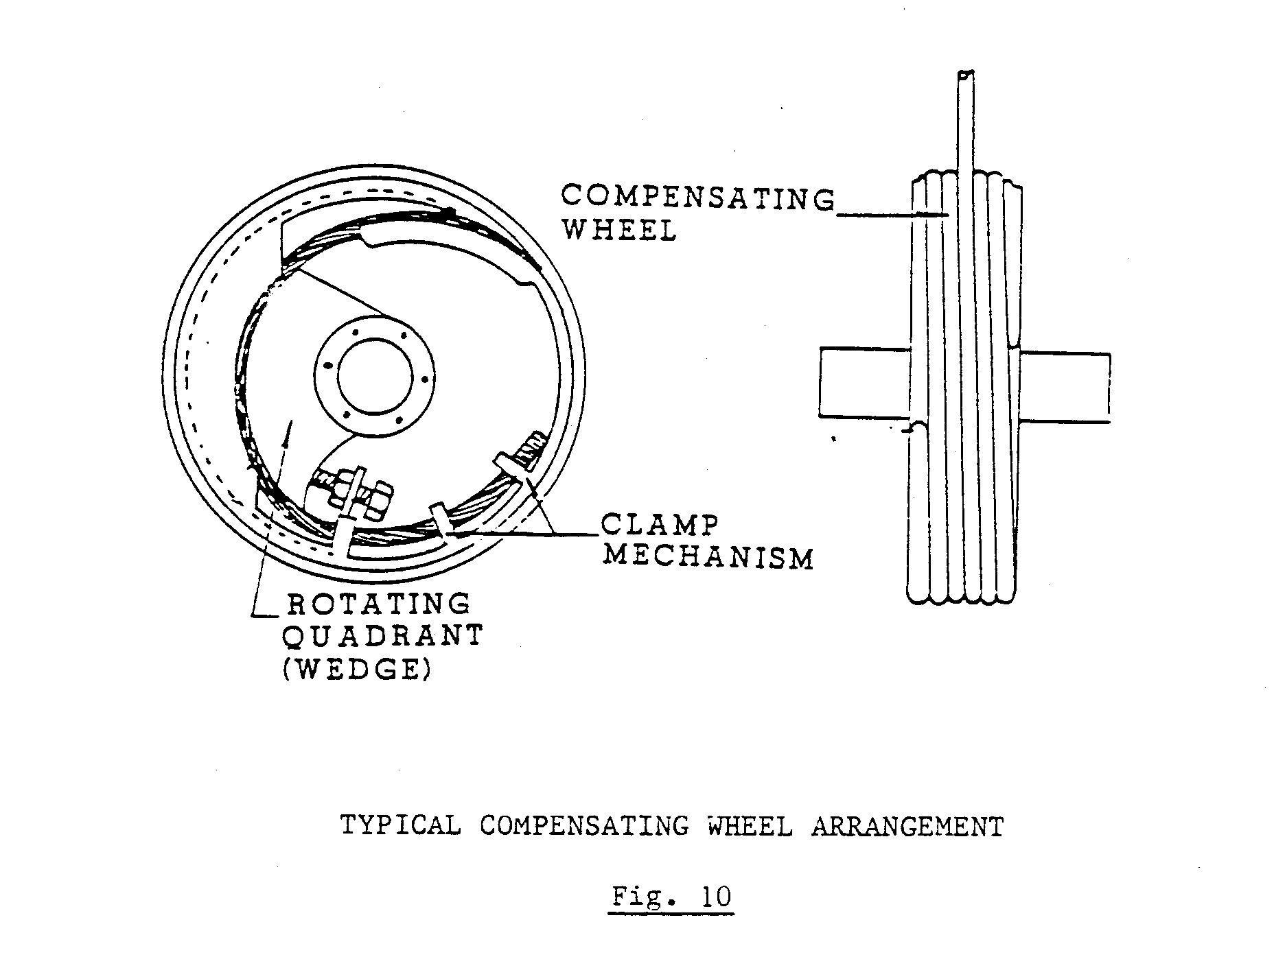
The compensating wheel is normally mounted in the gap between the bridle transoms of the conveyance, with a fixed axle held in dead eyes below the crosshead, as shown in Fig. 11.

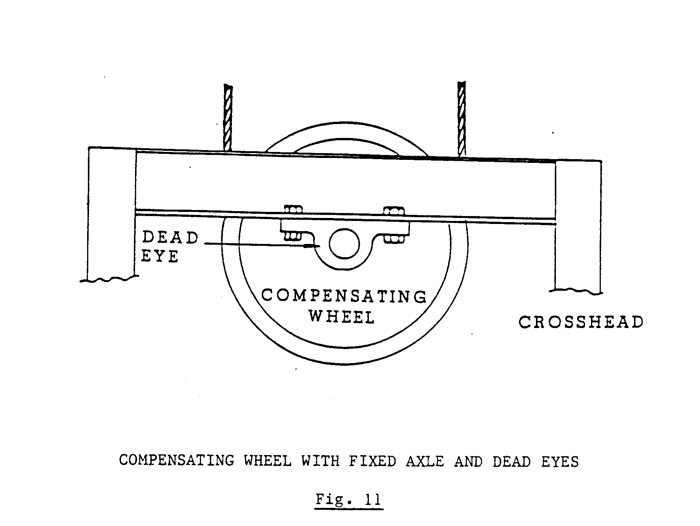
An alternative method is to key the compensating wheel on to a shaft which revolves in plummer blocks of some kind. Should the winder layout dictate so, the compensating wheel may be arranged at slight angles to the normal position with an intermediate link in the form of a semi-articulated suspension yoke.
Another method is where holes are bored through the members of the crosshead to fit the shaft as illustrated in Fig. 12.

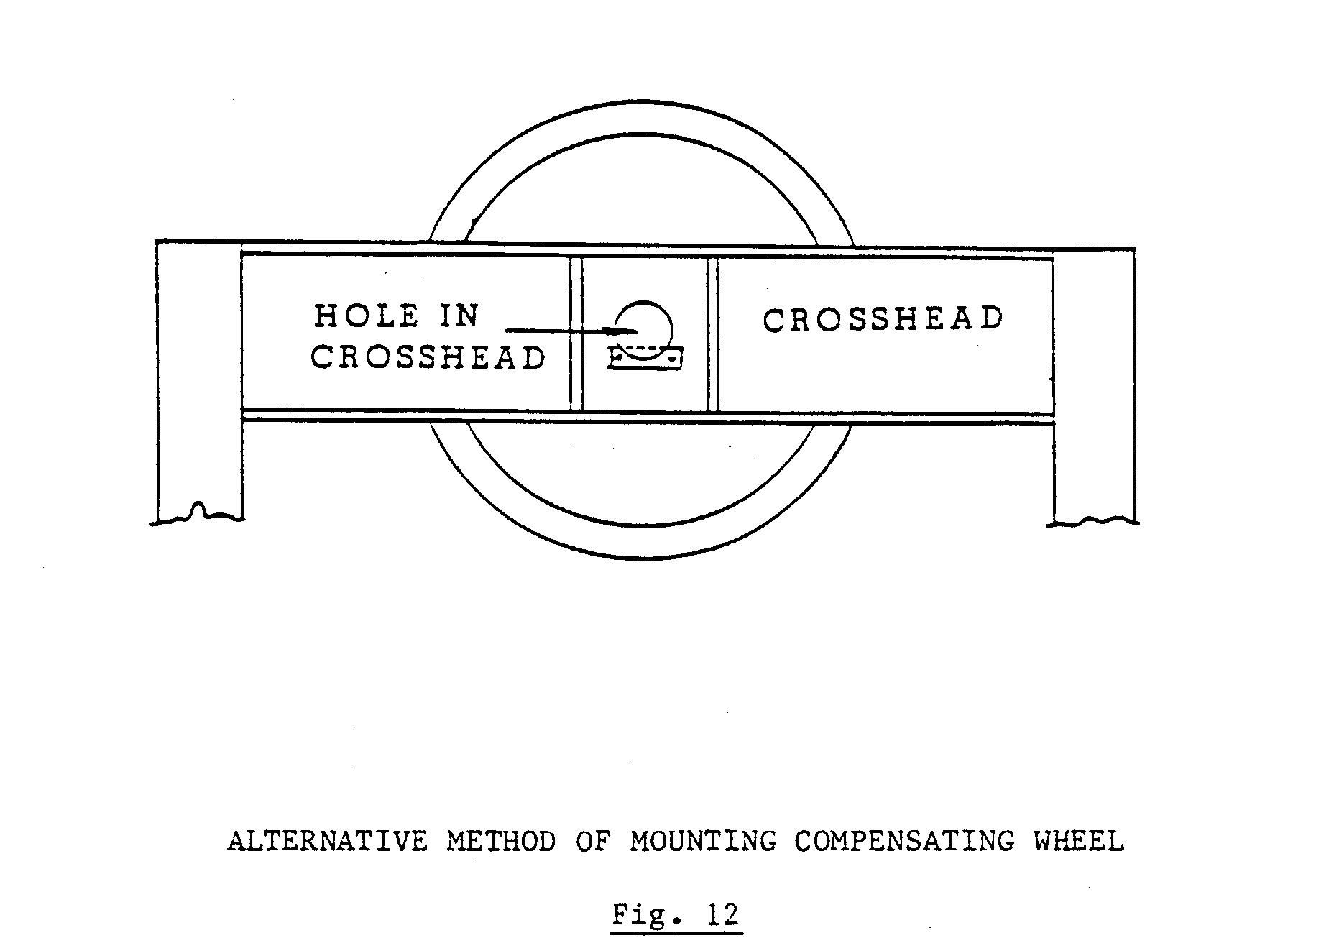
THE GUILLOTINE AND ITS PURPOSE

In place of the usual spectacle plate, a downward-facing guillotine is installed. When the conveyance reaches the guillotine, the latter is so positioned that it embeds itself into the turns of rope wrapped around the compensating wheel. It has been found that it is relatively easy to cut the rope when it is under tension on the compensating wheel. Tests carried out have shown that a single rope can be cut by a guillotine, using a force, which is only half as great as that required to open a detaching hook. Fig. 13 illustrates a compensating wheel in the overwind position.

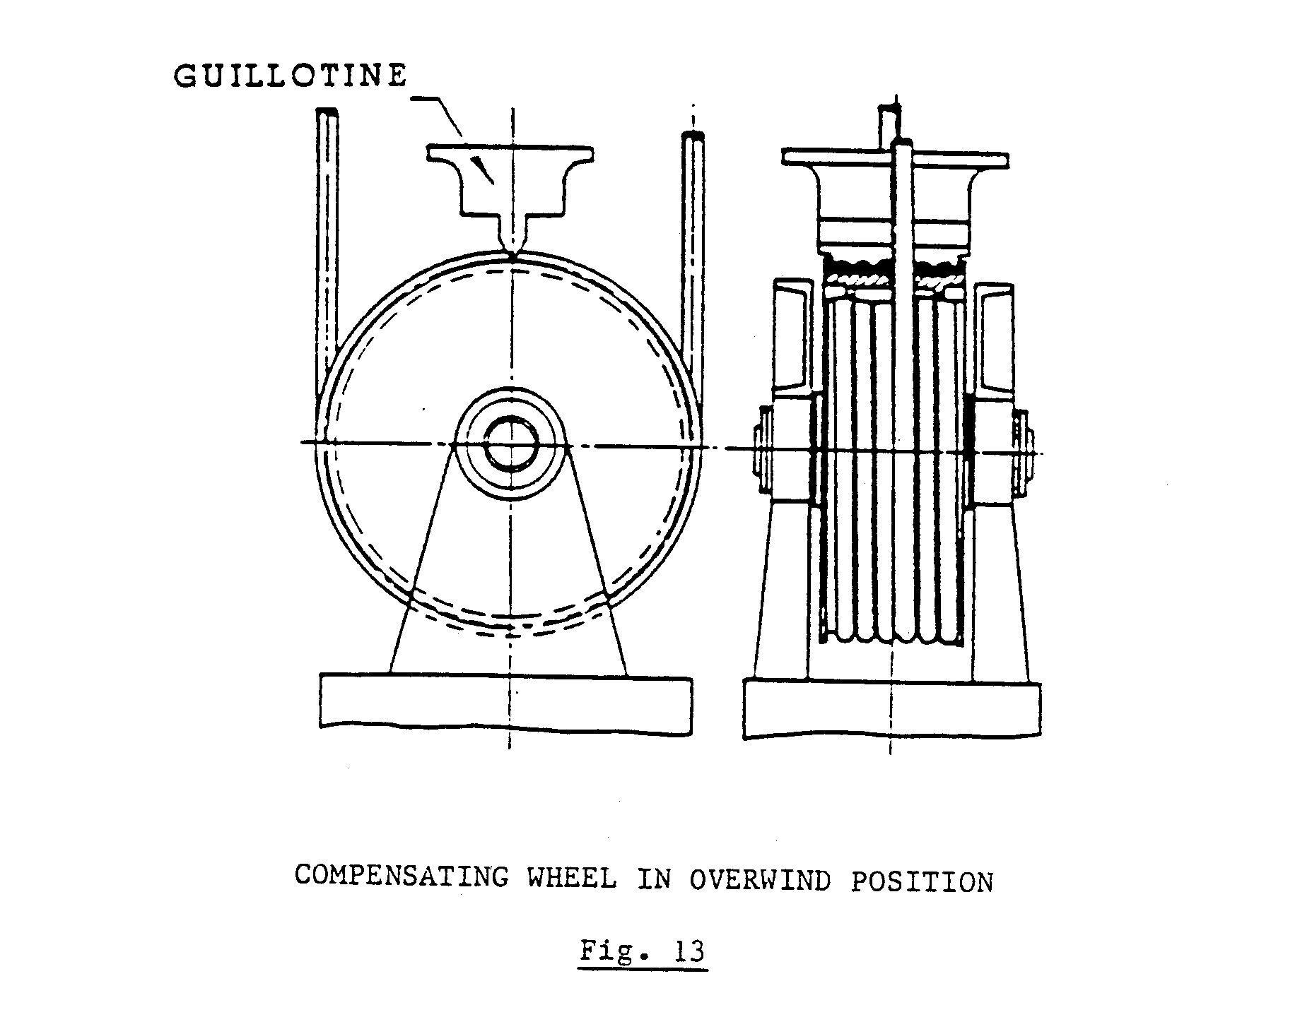

THE PURPOSE OF A CROSSHEAD AND ITS COMPONENTS

In sinking shafts the method of transporting men and material is by means of a kibble, which is attached to the end of the winding rope. A crosshead is employed to steady the kibble, which runs in two guide ropes. There is no permanent connection between the winder rope and the crosshead, which rests on the crosshead stopper, attached to the rope above the winding rope socket. Fig. 14 attached to the rope above the winding rope socket. Fig. 14 illustrates a crosshead and its components.

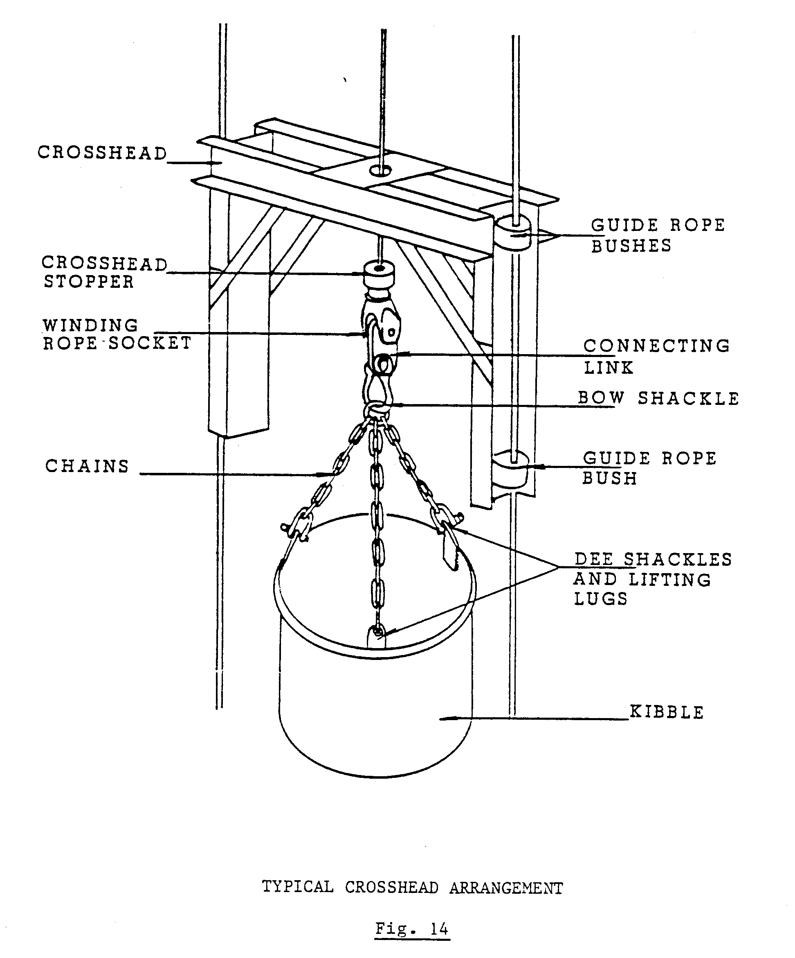
The winding rope is threaded through a centre bush in the crosshead. After the rope has been threaded through, the rope connection is made.
The triple branch chain sling is connected to the winding socket by means of a connecting link and bow shackle. The chains are connected to the kibble by means of Dee shackles to the lifting lugs on the kibble.

LOCATION OF CRASH BEAMS, CRASH DOORS, JACK CATCHES, TRIGGER AND ARRESTORS DURING SINKING OPERATIONS

When solid guides are installed in the headgear of a sinking shaft, jack catches are installed inside the solid guide device. The kibble is equipped with catch rings, which enter the jack catches in case of an overwind. Kibble damage is rife and the rotundity of the kibble should be checked daily. If the kibble is deformed, it will not enter the jack catches.
Crash doors in the headgear close if the kibble passes through them. This prevents the kibble from falling into the shaft in case detachment occurs and if the kibble is not held in the jack catches.
The crash doors are “triggered off” by means of a trip wire, which is mounted across the compartment. When the crosshead makes contact with the trip wire, the trip wire operates the latching device and disengages the door latch, allowing the crash doors to close.
The location of the crash beams, crash doors, jack catches and trigger arrangements is illustrated in Fig. 15.

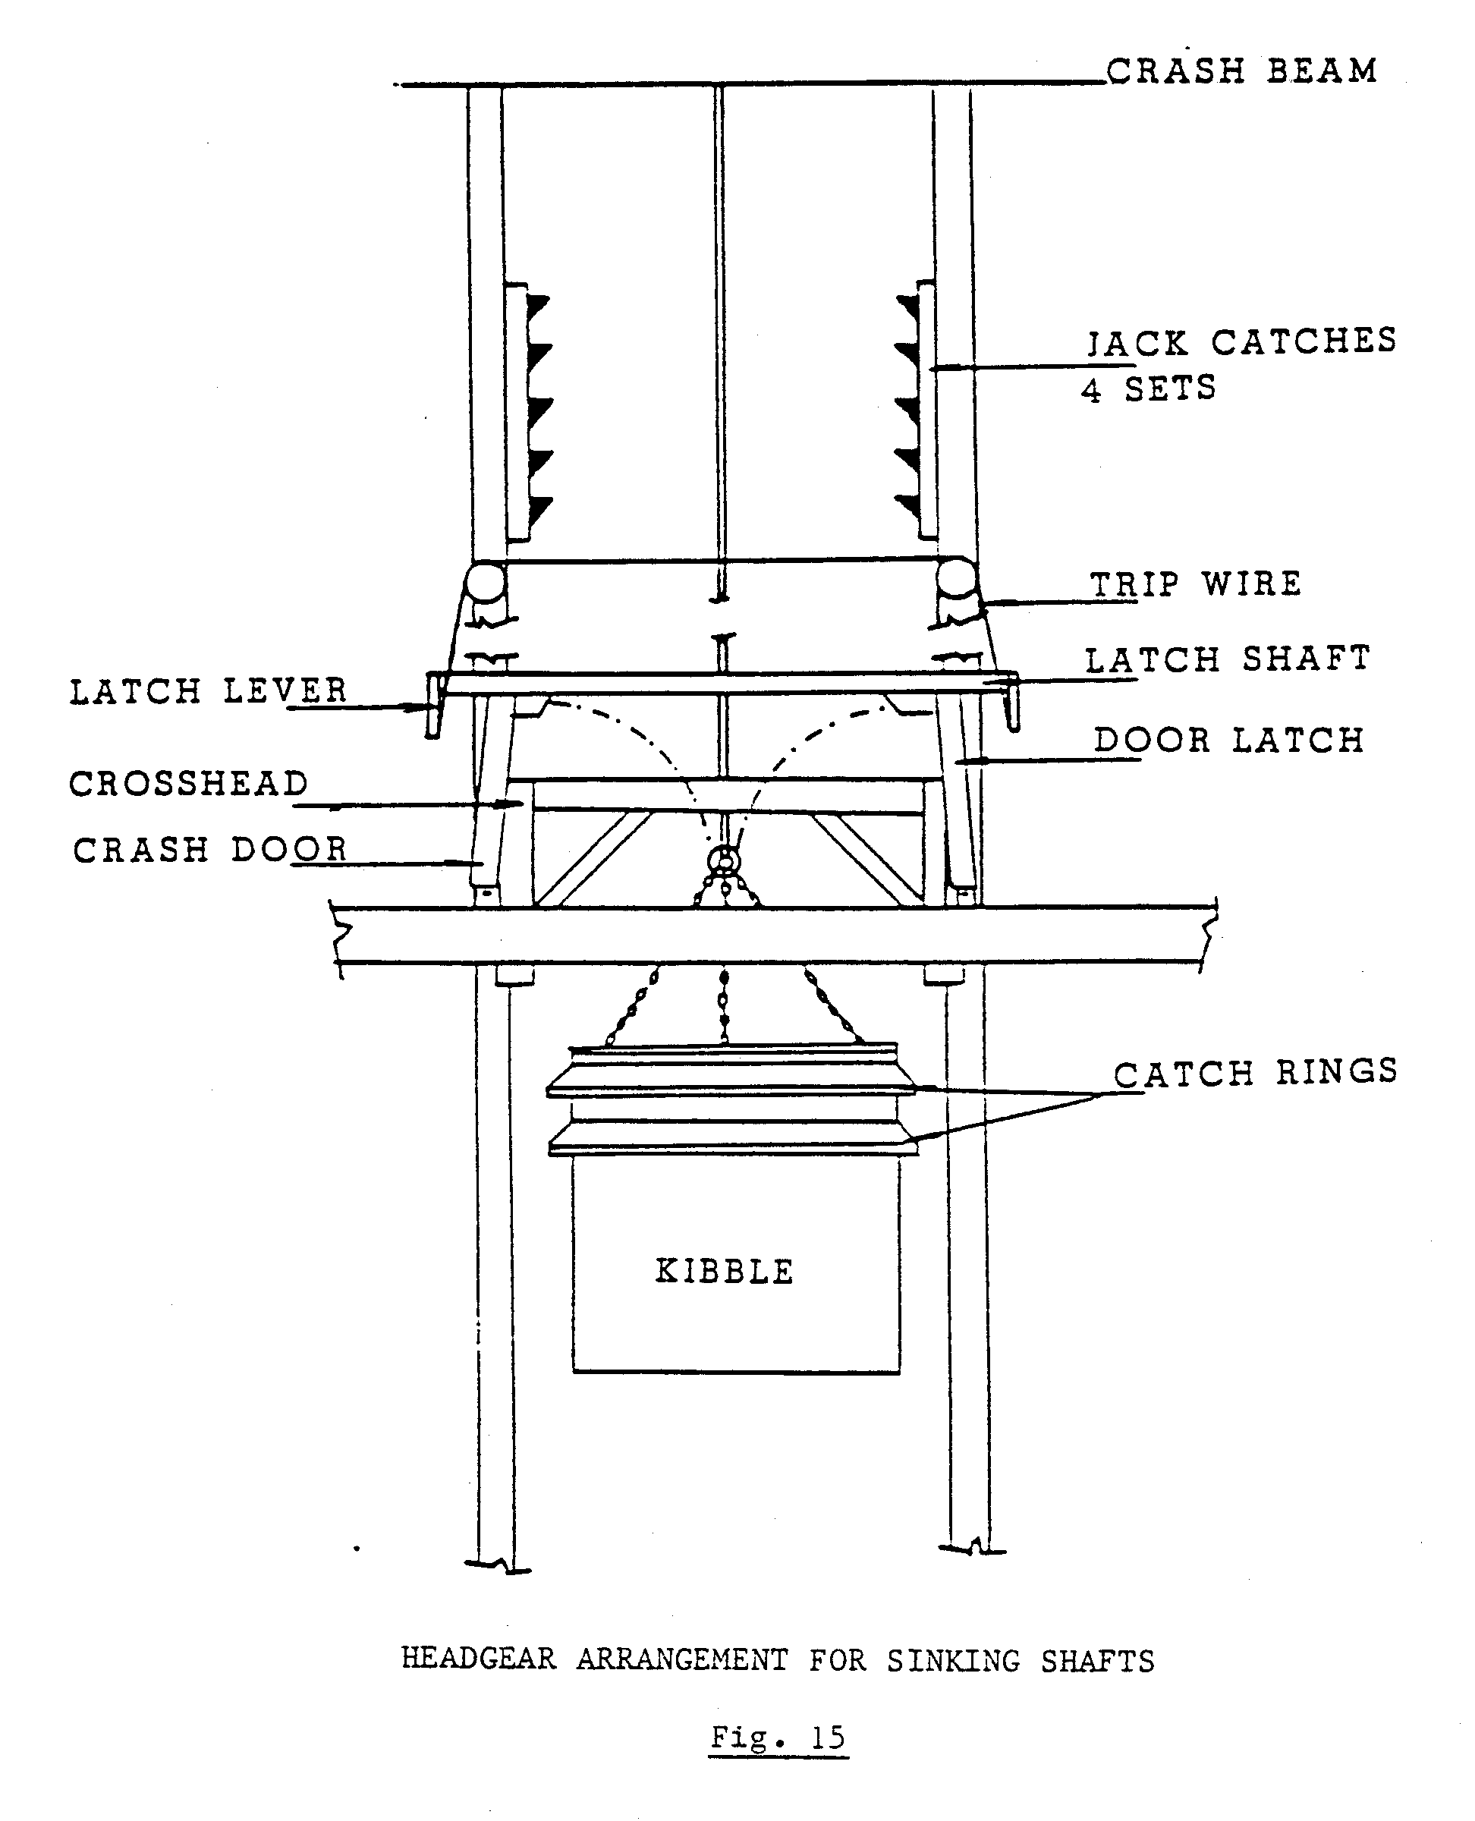
Fig. 16 illustrates where the trigger arrangements are mounted above the jack catches.

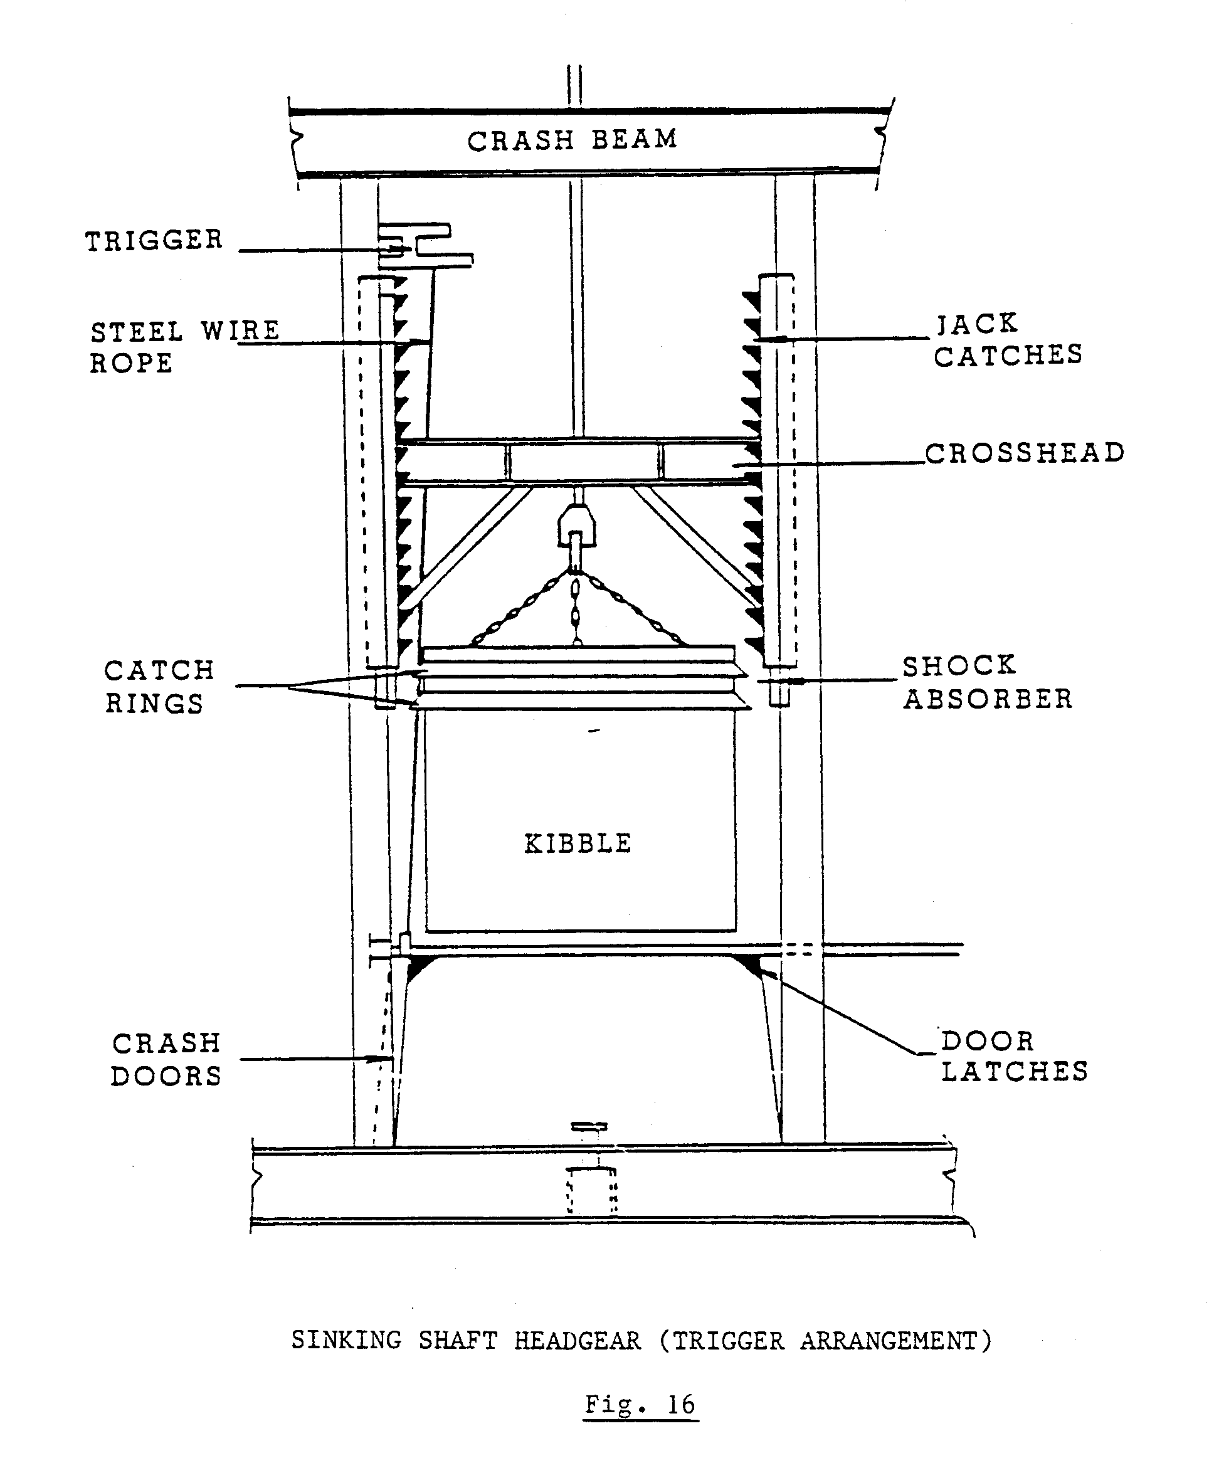
As illustrated in Fig. 16, jack catches are installed in the solid guide device. The trigger device is so mounted, that when the kibble enters the jack catches, only then will it trigger off the crash doors below. In the event of an overwind, all crash doors will close, thus preventing anything from falling down any other compartment.

Fig. 17 illustrates the trigger arrangement.

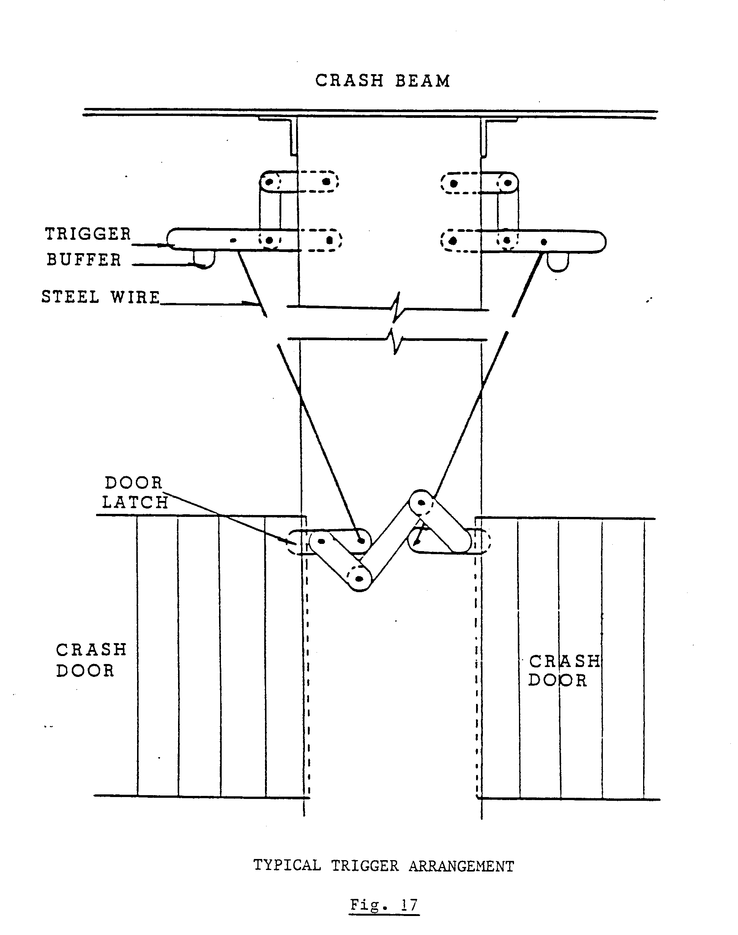
The jack catches are mounted in the guides, which give them a sliding effect. Below each jack arrangement, a hydraulic shock absorber (arrestor) is mounted to overcome the shock load of the kibble should it fall back onto the jack catches.
Hydraulic arrestors are also mounted below the crash doors. As the crash doors are of a heavy steel construction, the arrestor will absorb the shock when the doors close in the event of an overwind.
All daily, monthly and yearly examinations must be carried out according to your mine’s standards.

